CHILD PROTECTION POLICY

Policy Review

This policy will be reviewed in full by the Governing Body on an annual basis.

The policy was last reviewed and agreed by the Governing Body on 00/00/00

It is due for review on 00/00/00

Signature …………………………………. Head Teacher

Date ……………………

Signature ………………….………………. Chair of Governors

Date ….…………………

C O N T E N T S
1 | Introduction
2 | Statutory Framework
3 | The Designated Senior Person
4 | The Governing Body
5 | School Procedures
6 | When to be Concerned
7 | Dealing with a Disclosure
8 | Confidentiality
9 | Communication with Parents
10 | Record Keeping
11 | Allegations Involving School Staff/Volunteers/DBS
 | policy
Appendix 1 | Indicators of Harm incl support links for sexting
Appendix 2 | Dfe Keeping Children safe in education Sept 2018-
 | part 1and Annex A
Appendix 3 | Safeguarding and ICT
Appendix 4 | Safety & Support Plan
 | for children / young people in education
Appendix 5 | Recording Form for Safeguarding Concerns
Appendix 6/7 | Safeguarding Declaration /Induction Sheet for new or
 | supply staff and regular visitors or volunteers .
Appendix 8 | Prevent and protecting Pupils from Violent Extremism+ how
 | social media is used to encourage travel to Syria and Iraq briefing note for
 | schools

- INTRODUCTION
Safeguarding is defined as protecting children from maltreatment, preventing impairment of health and/or development, ensuring that children grow up in the provision of safe and effective care and taking action to enable all children to have the best life chances. (Working Together to Safeguard Children, DfE, 2018, pg.6)

This Child Protection Policy forms part of a suite of documents and policies which relate to the safeguarding responsibilities of the school. The range of people who will refer to the policy are teaching staff, support & lunch staff, parent helpers, volunteers, supply staff etc. as well as young people in the setting.

All external visitors including Trustees, supply teachers, volunteers, contractors and speakers will be made aware of the information contained within our safeguarding policy and their responsibility to comply via the school

See visitors’ policy

Links with other Policies

This safeguarding policy has obvious links with the wider safeguarding agenda: when reviewing our policy, links will be made with other relevant guidelines and procedures such as the anti-bullying policy, guidance on safer recruitment, prevent and Allegations of abuse made against teachers and other staff. In particular this policy should be read in conjunction with the Safeguarding Policy , Safer Recruitment Policy, Behaviour Policy, Physical Intervention Policy, Anti-Bullying Policy, Code of Conduct/Staff Behaviour Policy, E-safety Policy and ICT Acceptable Usage Policy.

- the safeguarding response to children who go missing from education; and

- the role of the designated safeguarding lead (including the identity of the designated safeguarding lead and any deputies).

Copies of policies and a copy of Part one of this document should be provided to staff at induction.

Purpose of a Child | To inform staff, parents, volunteers and governors about
Protection Policy | the school's responsibilities for safeguarding children.
 | To enable everyone to have a clear understanding of how
 | these responsibilities should be carried out.
School Staff & Volunteers | School staff and volunteers are particularly well placed to
 | observe outward signs of abuse, changes in behaviour
 | and failure to develop because they have daily contact
 | with children.
 | All school staff will receive appropriate safeguarding
 | children training (which is updated regularly), so that they
 | are knowledgeable and aware of their role in the early
 | recognition of the indicators of abuse or neglect and of
 | the appropriate procedures to follow. |  | It is good practice
 | for the Designated Senior Person to deliver an annual
 | update. And in xxxxx will provide an update every
 | September In addition all staff members will receive
 | safeguarding and child protection updates (for example,

via email, e-bulletins and staff meetings), as required, but
at least annually, to provide them with relevant skills and

knowledge to safeguard children effectively

Temporary staff and volunteers will be made aware of the

safeguarding policies and procedures by the Designated
Senior Person. -including Child Protection Policy and
staff behaviour policy (code of conduct), the
safeguarding response to children who go missing from
education; and the role of the designated safeguarding
lead (including the identity of the designated

safeguarding lead and any deputies).

Mission Statement | Establish and maintain an environment where children
 | feel secure, are encouraged to talk, and are listened to
 | when they have a worry or concern.
 | Establish and maintain an environment where school
 | staff and volunteers feel safe, are encouraged to talk and
 | are listened to when they have concerns about the safety
 | and well being of a child.
 | Ensure children know that there are adults in the school
 | whom they can approach if they are worried.
 | Ensure that children, who have additional/unmet needs
 | are supported appropriately. This could include referral to
 | early help services or specialist services if they are a
 | child in need or have been / are at risk of being abused
 | and neglected
 | Include opportunities in the PSHE curriculum for children
 | to develop the skills they need to recognise and stay safe
 | from abuse.
 | Contribute to the five outcomes which are key to
 | children’s wellbeing:
 |  | be healthy
 |  | stay safe
 |  | enjoy and achieve
 | make a positive contribution
 |  | achieve economic wellbeing

Consider how children may be taught about safeguarding, including online, through teaching and learning opportunities, as part of providing a broad and balanced curriculum.

Staff members working with children are advised to maintain an attitude of ‘it could happen here’ and ‘it could be happening to this child’, where safeguarding is concerned. When concerned about the welfare of a child, staff members should always act in the interests of the child.

The Islamic Context
The model for human behaviour and interaction has been given to us by Islam and the Prophet Muhammad (peace be upon him).

In the Qur’aan (the holy book in Islam) the Almighty Lord has stated: “The (faithful) servants of the Beneficient are those who walk upon the earth modestly.” (Al Furqaan 25:63).

The following are some of the Hadeeth (narrations) of the
Prophet (PBUH):

”(On the Day of Resurrection) there will be nothing heavier in the scale than good character (and polite manners).”

“I have been sent (by the Lord, as a Messenger) for the perfection of human conduct.”

“The true believer is one from whom people are safe with their lives and wealth.”

“He is not from amongst us who doesn’t show respect to his elders and does not show affection towards his youngsters.”

“Show mercy (be kind) to those on earth and He who is in the heavens will have mercy upon you.

Implementation, Monitoring The policy will be reviewed annually by the governing
and Review of the Child body. It will be implemented through the school’s

Protection Policy induction and training programme, and as part of day to day practice. Compliance with the policy will be monitored by the Designated Senior Person and through staff performance measures.

2. STATUTORY FRAMEWORK

In order to safeguard and promote the welfare of children, the school will act in accordance with the following legislation and guidance:

The Children Act 1989 The Children Act 2004
Education Act 2002 (Section 175/157)

Outlines that Local Authorities and School Governing Bodies have a responsibility to “ ensure that their functions relating to the conduct of school are exercised with a view to safeguarding and promoting the welfare of children who are its pupils”.

Local Safeguarding Children Board Inter-agency Child Protection and Safeguarding Children Procedures (Electronic)

Keeping Children Safe in Education (DfE, September 2018)

Keeping Children Safe in Education: Part One- information for all school and college staff (DfE, September 2018) – APPENDIX 1

Working Together to Safeguard Children (DfE Sept 2018)

The Education (Pupil Information) (England) Regulations 2005

Sexual Offences Act (2003)

Section 26, The Counter Terrorism and Security Act 2015 (PREVENT duty) Female Genital Mutilation Act 2003 (Section 74 ,Serious Crime Act 2015)
Anti-social Behaviour, Crime and Policing Act 2014 (makes it a criminal offence to force someone to marry. Includes taking someone overseas to force them to marry (whether or not the forced marriage takes place).

Keeping Children Safe in Education (DfE 2018) states that governing bodies and proprietors should ensure that the school or college contributes to multi-agency working in line with statutory guidance Working together to safeguard children.

Furthermore it also states that governing bodies and proprietors of all schools and colleges should ensure that their safeguarding arrangements take into account the procedures and practice of the local authority as part of inter-agency safeguarding procedures set up by the LSCB

The Prevent duty Departmental advice for schools and childcare providers June 2015 and the latest guidance on prevent Keeping Children Safe in Education – DFE, September 2018 – see appendix 2 will also be adhered to by the school hence: All staff will undertake Wrap training provided by the local prevent team in the Lancashire constabulary School staff and childcare providers should understand when it is appropriate to make a referral to the Channel programme. Channel is a programme which focuses on providing support at an early stage to people who are identified as being vulnerable to being drawn into terrorism. It provides a mechanism for schools to make referrals if they are concerned that an individual might be vulnerable to radicalisation. An individual’s engagement with the programme is entirely voluntary at all stages. Detailed guidance on Channel is available. An online general awareness training module on Channel is available and will be undertaken by all school staff and other front-line workers. It provides an introduction to the topics covered by this advice, including how to identify factors that can make people vulnerable to radicalisation, and case studies illustrating the types of intervention that may be appropriate, in addition to Channel. All Staff must read Dfe briefing on

How social media is used to encourage travel to Syria and Iraq. See appendix 8

- THE DESIGNATED SENIOR PERSON (referred to in ‘Keeping Children Safe in Education (DFE, September 2018 )as Designated Safeguarding Lead'-DSL)

Governing bodies and proprietors have ensured that xxxx designates are both part of the Senior Leadership Team that lead responsibility for child protection. Both have status and authority within the school to carry out the duties of the post including committing resources and, where appropriate, supporting and directing other staff.

xxxxx Ensures that during term time the designated safeguarding lead and or a deputy will always be available during school hours) for staff in the school or college to discuss any safeguarding concerns and individual arrangement for out of hours/out of term activities will be: All staff have Mobile phones details of the Designated Lead and the Deputy

The Designated Senior Person for Child Protection in this school is:

NAME: xxxx
A Deputy DSP should be appointed to act in the absence/unavailability of the DSP.

The Deputy Designated Senior Person for Child Protection in this school is:

NAME: xxxxx

The broad areas of responsibility for the Designated Senior Person are:

- Managing referrals and cases

Refer all cases of suspected abuse or neglect to the Local Authority Children’s Services (Safeguarding and Specialist Services) , Police (cases where a crime may have been committed) and to the Channel programme where there is a radicalisation concern

Liaise with the Head Teacher or Principal to inform him/ her of issues- especially ongoing enquiries under Section 47 of the Children Act 1989 and police investigations

Act as a source of support, advice and expertise to staff on matters of safety and safeguarding and when deciding whether to make a referral by liaising with relevant agencies

Support staff who make referrals

Share information with appropriate staff in relation to a child’s looked after (CLA) legal status (whether they are looked after under voluntary arrangements with consent of parents or on an Interim Care Order or Care Order) and contact arrangements with birth parents or those with parental responsibility.

Ensure they have details of the CLA’s social worker and the name of the virtual school

Head Teacher in the authority that looks after the child.

- Training

The Designated Senior Person should undergo formal training ever two years . However The DSP should also undertake Prevent awareness training In addition to this training, their knowledge and skills should be refreshed (for example via e-bulletins, meeting other DSPs, or taking time to read and digest safeguarding developments) at least annually to:

- Understand the assessment process for providing early help and intervention, for example through locally agreed common and shared assessment processes such as early help assessments

- Have a working knowledge of how local authorities conduct a child protection case conference and a child protection review conference and be able to attend and contribute to these effectively when required to do so

- Ensure each member of staff has access to and understands the school’s or college’s safeguarding and child protection policy and procedures, especially new and part time staff

- Be alert to the specific needs of children in need, those with special educational needs and young carers

- Understand and support the school or college with regards to the requirements of the Prevent duty and are able to provide advice and support to staff on protecting children from the risk of radicalisation

- Be able to keep detailed, accurate, secure written records of concerns and referrals

- Obtain access to resources and attend any relevant or refresher training courses

- Encourage a culture of listening to children and taking account of their wishes and feelings, among all staff, in any measures the school or college may put in place to protect them

All Staff :

should receive safeguarding training (including online safety) that is regularly updated but at least annually.

Should receive safeguarding training (including online safety) at induction

Should receive safeguarding and child protection updates (for example via email, e-bulletins and staff meetings) as required but at least annually

Should receive training on harmful behaviour linked to safeguarding issues that can children in danger (i.e. drug taking, alcohol abuse, truanting and sexting.

Should receive training on peer on peer abuse (including online peer on peer abuse such as cyberbullying and sexting) and be clear as to the school/college’s policy and procedures with regards to peer on peer abuse)

Should receive training on ‘sexting’ to ensure that all members of staff know how to respond to sexting concerns appropriately and in line with the school/college policy. Staff should also be made aware how to identify concerning behaviours which may be linked to sexting.

Will receive mental health and well-being training

- Raising Awareness

The designated safeguarding person should ensure the school or college’s policies are known, understood and used appropriately.

Ensure the school or college’s safeguarding and child protection policy is reviewed annually and the procedures and implementation are updated and reviewed regularly, and work with governing bodies or proprietors regarding this.

Ensure the safeguarding and child protection policy is available publicly and parents are aware of the fact that referrals about suspected abuse or neglect may be made and the role of the school or college in this.

Link with the Local Safeguarding Children’s Board (LSCB) to make sure staff are aware of training opportunities and the latest local policies on safeguarding.

Where children leave the school or college, ensure the file for safeguarding and any child protection information is sent to any new school /college as soon as possible but transferred separately from the main pupil file.

Schools should obtain proof that the new school/education setting has received the safeguarding file for any child transferring and then destroy any information held on the child in line with data protection guidelines

4. THE GOVERNING BODY

Governing bodies and proprietors must ensure that they comply with their duties under legislation. They must also have regard to this guidance to ensure that the policies, procedures and training in their schools or colleges are effective and comply with the law at all times.

Governing bodies and proprietors should have a senior board level (or equivalent) lead to take leadership responsibility for their schools or college’s safeguarding arrangements.

The nominated governor for child protection is:

NAME xxxx
In particular the Governing Body and proprietors must ensure:

their contribution to inter-agency working, which includes providing a coordinated offer of early help when additional needs of children are identified

ensuring that an effective child protection policy is in place, together with a staff behaviour policy

ensuring staff are provided with Part One of Keeping Children Safe in Education (DfE 2018)

– Appendix 1 and are aware of specific safeguarding issues

ensuring that staff induction is in place with regards to child protection and safeguarding

appointing an appropriate senior member of staff to act as the Lead Designated Senior Person. It is a matter for individual schools and colleges as to whether they choose to have one or more Deputy Designated Senior Person.

ensuring that all of the Designated Senior Persons (including deputies) should undergo formal child protection training every two years (in line with LCSB guidance) and receive regular (annual) safeguarding refreshers (for example via e-bulletins, meeting other DSPs, or taking time to read and digest safeguarding developments)

prioritising the welfare of children and young people and creating a culture where staff are confident to challenge senior leaders over any safeguarding concerns

ensuring that children are taught about safeguarding, including online safety. Schools should consider this as part of providing a broad and balanced curriculum

ensuring appropriate filters and appropriate monitoring systems are in place to safeguard children from potentially harmful and inappropriate online material. Additional information to support governing bodies and proprietors is provided in Annex C of Keeping Children Safe in Education(DFE 2018). -available from the school for hard copies

Having a senior board level lead to take leadership responsibility for the organisation’s safeguarding arrangements

A member of the Governing Body (usually the Chair) is nominated to liaise with the local authority and/or partner agencies on issues of child protection and in the vent of allegations of abuse made against the headteacher

Safeguarding policies and procedures are reviewed annually

- SCHOOL PROCEDURES - STAFF RESPONSIBILITIES when to be concerned

If staff have any concerns about a child’s welfare, they should act on them immediately. If staff have a concern, they should follow this policy and speak to the Designated Senior Person/DSL(or deputy). The designated safeguarding lead (and any deputies) are most likely to have a complete safeguarding picture and be the most appropriate person to advise on the response to safeguarding concerns.

Any staff member should be able to make a safeguarding referral to Children’s Services if necessary.

All staff should be aware of the process for making referrals to Children’s Services and for statutory assessments under the Children Act 1989, especially section 17 (children in need) and section 47 (a child suffering, or likely to suffer, significant harm - from abuse or neglect) that may follow a referral, along with the role they might be expected to play in such assessments.

Staff should not assume a colleague or another professional will take action and share information that might be critical in keeping children safe. They should be mindful that early information sharing is vital for effective identification, assessment and allocation of appropriate service provision.

Options will then include:

managing any support for the child internally via the school or college’s own pastoral support processes;

an early help assessment; or

a referral for statutory services, for example as the child might be in need, is in need or suffering or likely to suffer significant harm from abuse or neglect.

Contextual Safeguarding

Safeguarding incidents and/or behaviours can be associated with factors outside the school or college and/or can occur between children outside the school or college. All staff, but especially
the designated safeguarding lead (or deputy) should be considering the context within which such incidents and/or behaviours occur. This is known as contextual safeguarding, which simply means assessments of children should consider whether wider environmental factors are present in a child’s life that are a threat to their safety and/or welfare.

Then Staff should speak to a DSP in their school or contact LOCAL Children’s Services (including out of hours) SEE BELOW

Child Protection

For Child Protection Procedures XXXXX must be notified immediately, if any member of Staff suspects that a child is suffering or likely to suffer from significant harm, from the following:

Physical Abuse; Sexual Abuse; Emotional Abuse or Neglect.

Staff from whom further advice maybe sought:

Headteacher: XXXXX

Useful Contacts

Child Protection and Safeguarding

First Response Early Intervention and Support Team XXXXX
(Local Authority Designated Officer) XXXX
Capita XXXXXX

Strategic Safeguarding Advice – XXXXXX

For social care referrals

If you are concerned about the safety or welfare of a child please phone:

Children's Social Care

Tel: XXXXX

LADO Referrals
XXXXXXX

LSCB Contact for Reviews and for Policy Changes

XXXXXXXX

Sexual Exploitation Project

XXXX

Referrals
Customer Service Centre |  | xxxx
Out of Hours / Emergency Duty Team (EDT) |  | xxxxxx
Schools Safeguarding
Allegations
Children missing Education (CME) Team

Always encourage the discussion to be with parents if appropriate.

6. WHEN TO BE CONCERNED

A child centred and coordinated approach to safeguarding:

Safeguarding and promoting the welfare of children is everyone’s responsibility. In order to fulfil this responsibility effectively, all professionals should make sure their approach is child centred. This means that they should consider, at all times, what is in the best interests of the child.

Schools and colleges and their staff form part of the wider safeguarding system for children. This system is based on the principle of providing help for families to stay together where it is safe for the children to do so, and looking at alternatives where it is not, whilst acting in the best interests of the child at all times..

Children who may require early help

All staff should be aware of the early help process, and understand their role in identifying emerging problems, sharing information with other professionals to support early identification and assessment of a child’s needs. It is important for children to receive the right help at the right time

to address risks and prevent issues escalating. This also includes staff monitoring the situation and feeding back to the Designated Senior Person any ongoing/escalating concerns so that consideration can be given to a referral to Children’s Services (Safeguarding and Specialist Services) if the child’s situation doesn’t appear to be improving.

If early help is appropriate, the designated safeguarding lead (or deputy) will generally lead on liaising with other agencies and setting up an inter-agency assessment as appropriate.

Any child may benefit from early help, but all school and college staff should be particularly alert to the potential need for early help for a child who:

- is disabled and has specific additional needs;

- has special educational needs (whether or not they have a statutory education, health and care plan);
- is a young carer;

- is showing signs of being drawn in to anti-social or criminal behaviour, including gang involvement and association with organised crime groups;
- is frequently missing/goes missing from care or from home;
- is misusing drugs or alcohol themselves;
- Is at risk of modern slavery, trafficking or exploitation;
is in a family circumstance presenting challenges for the child, such as substance abuse, adult
mental health problems or domestic abuse;
- has returned home to their family from care;
- is showing early signs of abuse and/or neglect;
- is at risk of being radicalised or exploited;
- is a privately fostered child.

School and college staff members should be aware of the main categories of maltreatment: physical abuse, emotional abuse, sexual abuse and neglect. They should also be aware of the indicators of maltreatment and specific safeguarding issues so that they are able to identify cases of children who may be in need of help or protection.

See Appendix 1 for information on indicators of abuse and for specific safeguarding issues.

Children with special educational needs and disabilities:

Additional barriers can exist when recognising abuse and neglect in this group of children.

This can include:

- Assumptions that indicators of possible abuse such as behaviour, mood and injury relate to the child’s impairment without further exploration;

- Assumptions that children with SEN and disabilities can be disproportionally impacted by things like bullying- without outwardly showing any signs;

- Communication barriers and difficulties

- Reluctance to challenge carers , (professionals may over empathise with carers because of the perceived stress of caring for a disabled child)

- Disabled children often rely on a wide network of carers to meet their basic needs and therefore the potential risk of exposure to abusive behaviour can be increased.

- A disabled child’s understanding of abuse.

- Lack of choice/participation

- Isolation

Peer on peer abuse

Education settings are an important part of the inter-agency framework not only in terms of evaluating and referring concerns to Children’s Services and the Police, but also in the assessment and management of risk that the child or young person may pose to themselves and others in the education setting.

If one child or young person causes harm to another, this should not necessarily be dealt with as abuse. When considering whether behaviour is abusive, it is important to consider:

Whether there is a large difference in power (for example age, size, ability, development) between the young people concerned; or

whether the perpetrator has repeatedly tried to harm one or more other children; or Whether there are concerns about the intention of the alleged perpetrator.

All staff should be aware that safeguarding issues can manifest themselves via peer on peer abuse. This is most likely to include, but may not be limited to:

- bullying (including cyberbullying);

- physical abuse such as hitting, kicking, shaking, biting, hair pulling, or otherwise causing physical harm;

- sexual violence and sexual harassment;

- sexting (also known as youth produced sexual imagery); and

- initiation/hazing type violence and rituals.

All staff should be aware that abuse is abuse and peer on peer abuse will never be tolerated or passed off as “banter”, “just having a laugh” or “part of growing up”. Furthermore they should recognise the gendered nature of peer on peer abuse (i.e. that it is more likely that girls will be victims and boys perpetrators), but that all peer on peer abuse is unacceptable and will be taken seriously.

The Madrasah recommends staff to use The Sexual Behaviours Traffic Light Tool by the Brook Advisory Service to help professionals; assess and respond appropriately to sexualised behaviour. The traffic light tool can be found at in the staff handbook or try the link below www.brook.org.uk/our-work/the-sexual-behaviours-traffic-light-tool.

Staff should recognise that children are capable of abusing their peers and should not be tolerated or passed off as “banter” or “part of growing up”.

In order to minimise the risk of peer on peer abuse the school:

Provides a developmentally appropriate PSHE curriculum which develops students understanding of acceptable behaviour and keeping themselves safe. (Examples should be listed here)

Have systems in place for any student to raise concerns with staff, knowing that they will be listened to, believed and valued. (Examples should be listed here)

Ensure victims, perpetrators and any other child affected by peer on peer abuse will be supported (state process/examples))

Develops robust risk assessments where appropriate (e.g. Using the Risk Assessment Management Plan and Safety and Support Plan tools).

Have relevant policies in place (e.g. behaviour policy).

Guidance on responding to and managing sexting incidents can be found at in the staff handbook.

All staff and volunteers should be aware that the main categories of abuse are:

Physical abuse Emotional abuse Sexual abuse

Neglect

FGM –Female Genital Mutilation Extremism

All staff and volunteers should be concerned about a child if he/she presents with indicators of possible significant harm – see Appendix 1 for details.

SAFEGUARDING PUPILS WHO ARE VULNERABLE TO EXPLOITATION, FORCED MARRIAGE, FEMALE GENITAL MUTILATION, OR TRAFFICKING

Staff should also refer to Part 5 of Keeping Children Safe in Education (DfE 2018) – ‘Child on child sexual violence and sexual harassment’:

https://www.gov.uk/government/publications/keeping-children-safe-in-education--2

Our safeguarding policy above through the school’s values, ethos and behaviour policies provides the basic platform to ensure children and young people are given the support to respect themselves and others, stand up for themselves and protect each other.

Our school keeps itself up to date on the latest advice and guidance provided to assist in addressing specific vulnerabilities and forms of exploitation.

Our staff are supported to recognise warning signs and symptoms in relation to specific issues, include such issues in an age appropriate way in their curriculum,

Our school works with and engages our families and communities to talk about such issues,

Our staff are supported to talk to families about sensitive concerns in relation to their children and to find ways to address them together wherever possible.

Our Designated Safeguarding Lead knows where to seek and get advice as necessary.

Our school brings in experts and uses specialist material to support the work we do.

Generally, in an abusive relationship the child may:

Appear frightened of the parent/s or other household members e.g. siblings or others outside of the home

Act in a way that is inappropriate to her/his age and development

(full account needs to be taken of different patterns of development and different ethnic groups)

Display insufficient sense of ‘boundaries’, lack stranger awareness Appear wary of adults and display ‘frozen watchfulness’
. SAFEGUARDING PUPILS WHO ARE VULNERABLE TO EXTREMISM,

10.1 Since 2010, when the Government published the Prevent Strategy, there has been an awareness of the specific need to safeguard children, young people and families from violent extremism. There have been several occasions both locally and nationally in which extremist groups have attempted to radicalise vulnerable children and young people to hold extreme views including views justifying political, religious, sexist or racist violence, or to steer them into a rigid and narrow ideology that is intolerant of diversity and leaves them vulnerable to future radicalisation.

10.2 XXXX values freedom of speech and the expression of beliefs / ideology as fundamental rights underpinning our society’s values. Both pupils and teachers have the right to speak freely and voice their opinions. However, freedom comes with responsibility and free speech that is designed to manipulate the vulnerable or that leads to violence and harm of others goes against the moral principles in which freedom of speech is valued. Free speech is not an unqualified privilege; it is subject to laws and policies governing equality, human rights, community safety and community cohesion.

The current threat from terrorism in the United Kingdom may include the exploitation of vulnerable people, to involve them in terrorism or in activity in support of terrorism. The normalisation of extreme views may also make children and young people vulnerable to future manipulation and exploitation. XXXX is clear that this exploitation and radicalisation should be viewed as a safeguarding concern.

The School seeks to protect children and young people against the messages of all violent extremism including, but not restricted to, those linked to Islamist ideology, or to Far Right / Neo Nazi / White Supremacist ideology, Irish Nationalist and Loyalist paramilitary groups, and extremist Animal Rights movement

PREVENTING VIOLENT EXTREMISM -
ROLES AND RESPONSIBILITIES OF THE SINGLE POINT OF CONTACT (SPOC)

The SPOC for the school is XXXX who is responsible for:

Ensuring that staff of the school are aware that you are the SPOC in relation to protecting pupils from radicalisation and involvement in terrorism;

Maintaining and applying a good understanding of the relevant guidance in relation to preventing pupils from becoming involved in terrorism, and protecting them from radicalisation by those who support terrorism or forms of extremism which lead to terrorism;

Raising awareness about the role and responsibilities of XXXX in relation to protecting pupils from radicalisation and involvement in terrorism;

Monitoring the effect in practice of the school’s RS curriculum and assembly policy to ensure that they are used to promote community cohesion and tolerance of different faiths

and beliefs;

Raising awareness within the school about the safeguarding processes relating to protecting pupils from radicalisation and involvement in terrorism;

Acting as the first point of contact within the school for case discussions relating to pupils who may be at risk of radicalisation or involved in terrorism;

Collating relevant information from in relation to referrals of vulnerable pupils into the

CONSTABULARY Counter- Terrorism Unit (GMPCTU)

attending LCCTU meetings as necessary and carrying out any actions as agreed; Reporting progress on actions to the LCCTU Co-ordinator; and

Sharing any relevant additional information in a timely manner.

CONSTABULARY Counter-Terrorism Unit and it aims to:

Establish an effective multi-agency referral and intervention process to identify vulnerable individuals;

Safeguard individuals who might be vulnerable to being radicalised, so that they are not at risk of being drawn into terrorist-related activity; and

Provide early intervention to protect and divert people away from the risks they face and reduce vulnerability

7. DEALING WITH A DISCLOSURE

If a child discloses that he or she has been abused in some way, the member of staff / volunteer should:

Listen to what is being said without displaying shock or disbelief Accept what is being said

Allow the child to talk freely

Reassure the child, but not make promises which it might not be possible to keep

Not promise confidentiality – it might be necessary to refer to Children’s Services: Safeguarding and Specialist Services

Reassure him or her that what has happened is not his or her fault Stress that it was the right thing to tell

Listen, only asking questions when necessary to clarify Not criticise the alleged perpetrator

Explain what has to be done next and who has to be told Make a written record (see Record Keeping)

Pass the information to the Designated Senior Person without delay

Support

Dealing with a disclosure from a child, and safeguarding issues can be stressful. The member of staff/volunteer should, therefore, consider seeking support for him/herself and discuss this with the Designated Senior Person.

If a school staff member receives a disclosure about potential harm caused by another staff member, they should see section 11 of this policy– Allegations involving school staff/volunteers

8. CONFIDENTIALITY

All practitioners should be confident of the processing conditions under the Data Protection Act 2018 and the GDPR which allow them to store and share information for safeguarding purposes, including information which is sensitive and personal, and should be treated as ‘special category personal data’

All concerns, discussions and decisions made and the reasons for those decisions should be recorded in writing. If in doubt about recording requirements staff should discuss with the designated safeguarding lead.

When a child has made a disclosure, the member of staff/volunteer should:

Record as soon as possible after the conversation. Use the school record of concern sheet wherever possible. (pro-forma available on the Hertfordshire Grid for Learning)

Record the date, time, place and any noticeable non-verbal behaviour and the words used by the child

Draw a diagram to indicate the position of any injuries

Record statements and observations rather than interpretations or assumptions Do not destroy the original records in case they are needed by a court

All records need to be given to the Designated Senior Person promptly. No copies should be retained by the member of staff or volunteer.

The Designated Senior Person will ensure that all safeguarding records are managed in accordance with the Education (Pupil Information) (England) Regulations 2005.

Where children leave the school or college, the Designated Senior Person should ensure their child protection file is transferred to the new school or college as soon as possible, ensuring secure transit, and confirmation of receipt should be obtained. For schools, this should be transferred separately from the main pupil file. Receiving schools and colleges should ensure key staff such as Designated Senior Persons and SENCOs or the named person with oversight for SEN in a college, are aware as required. If the child has an allocated social worker, they will also inform them of the change of school.

In addition to the child protection file, the Designated Senior Person should also consider if it would be appropriate to share any information with the new school or college in advance of a child leaving. For example, information that would allow the new school or college to continue supporting victims of abuse and have that support in place for when the child arrives.

Safeguarding children raises issues of confidentiality that must be clearly understood by all staff/volunteers in schools.

All staff in schools, both teaching and non-teaching staff, have a responsibility to share relevant information about the protection of children with other professionals, particularly the investigative agencies (Children’s Services: Safeguarding and Specialist Services and the Police).

If a child confides in a member of staff/volunteer and requests that the information is kept secret, it is important that the member of staff/volunteer tell the child in a manner appropriate to the child’s age/stage of development that they cannot promise complete confidentiality – instead they must explain that they may need to pass information to other professionals to help keep the child or other children safe.

Staff/volunteers who receive information about children and their families in the course of

their work should share that information only within appropriate professional contexts.

- COMMUNICATION WITH PARENTS

XXXX will:

Ensure the Child Protection Policy is available publicly either via the school or college website or by other means.

Parents should be informed prior to referral, unless it is considered to do so might place the child at increased risk of significant harm by:

The behavioural response it prompts e.g. a child being subjected to abuse, maltreatment or threats / forced to remain silent if alleged abuser informed;

Leading to an unreasonable delay;

Leading to the risk of loss of evidential material;

(The school may also consider not informing parent(s) where is would place a member of staff at risk).

Ensure that parents have an understanding of the responsibilities placed on the school and staff for safeguarding children.

Where reasonably possible schools and colleges should hold more than one emergency contact number for their pupils and students

10. RECORD KEEPING- school procedures

When a child has made a disclosure, the member of staff/volunteer should:

Make brief notes as soon as possible after the conversation. Use the school record of concern sheet wherever possible. (SEE APPENDIX 5)

Not destroy the original notes in case they are needed by a court

Record the date, time, place and any noticeable non-verbal behaviour and the words used by the child

Draw a diagram to indicate the position of any injuries

Record statements and observations rather than interpretations or assumptions

All records need to be given to the Designated Senior Person promptly. No copies should be retained by the member of staff or volunteer.

The Designated Senior Person will ensure that all safeguarding records are managed in accordance with the Education (Pupil Information) (England) Regulations 2005.

If any member of staff is concerned about a child he or she must inform the Designated Senior Person. The Designated Senior Person will decide whether the concerns should be referred to Children’s Services: Safeguarding and Specialist Services. If it is decided to make a referral to Children’s Services: Safeguarding and Specialist Services this will be discussed with the parents, unless to do so would place the child at further risk of harm.

While it is the DSPs role to make referrals, any staff member can make a referral to Children’s Services. If a child is in immediate danger or is at risk of harm (e.g. concern that a family might have plans to carry out FGM), a referral should be made to Children’s Services and/or the Police immediately. Where referrals are not made by the DSP, the DSP should be informed as soon as possible.

If a teacher ( persons employed or engaged to carry out teaching work at schools and other institutions in England) , in the course of their work in the profession, discovers that an act of Female Genital Mutilation (FGM) appears to have been carried out on a girl under the age of 18 the teacher must report this to the police. This is a mandatory reporting duty. See Appendix 1-Keeping Children Safe in Education (DfE 2018): Annex A for further information.

If the allegations raised are against other children, the school should follow section 4.4 of the Hertfordshire Safeguarding Children Board Procedures Manual – Children Who Abuse Others . Please see the school’s anti-bullying policy for more details on procedures to minimise the risk of peer on peer abuse.

The member of staff must record information regarding the concerns on the same day. The recording must be a clear, precise, factual account of the observations. (record of concern pro-forma is available on the Hertfordshire Grid for Learning).

Particular attention will be paid to the attendance and development of any child about whom the school has concerns, or who has been identified as being the subject of a child protection plan and a written record will be kept.

If a pupil who is/or has been the subject of a child protection plan changes school, the Designated Senior Person will inform the social worker responsible for the case and transfer the appropriate records to the Designated Senior Person at the receiving school, in a secure manner, and separate from the child’s academic file.

The Designated Senior Person is responsible for making the senior leadership team aware of trends in behaviour that may affect pupil welfare. If necessary, training will be arranged

If a pupil who is/or has been the subject of a child protection plan changes school, the Designated Senior Person will inform the social worker responsible for the case and transfer the appropriate records to the Designated Senior Person at the receiving school, in a secure manner, and separate from the child’s academic file.

11. ALLEGATIONS INVOLVING SCHOOL STAFF/VOLUNTEERS

An allegation is any information which indicates that a member of staff/volunteer may have:

Behaved in a way that has, or may have harmed a child

Possibly committed a criminal offence against/related to a child

Behaved towards a child or children in a way which indicates s/he would pose a risk of harm if they work regularly or closely with children

This applies to any child the member of staff/volunteer has contact within their personal, professional or community life.

What xxxxx staff do if they have concerns about safeguarding practices within the school.

All staff and volunteers should feel able to raise concerns about poor or unsafe practice and potential failures in the school or education setting’s safeguarding arrangements. Appropriate whistleblowing procedures, which are suitably reflected in staff training and staff behaviour policies, are in place for such concerns to be raised with the schools’ senior leadership team.

If staff members have concerns about another staff member then this should be referred to the Head Teacher. Where there are concerns about the Head Teacher this should be referred to the Chair of Governors.

The Chair of Governors in this school is:

NAME:

CONTACT NUMBER:

xxxx
from school

In the absence of the Chair of Governors, the Vice Chair should be contacted. The Vice Chair in this school is:

NAME: xxxxxx CONTACT NUMBER: from school

_______________________ _________________________

In the event of allegations of abuse being made against the Head Teacher, where the Head Teacher is also the sole Proprietor of an independent school or where a staff member feels unable to raise an issue with their employer or feels that their genuine concerns are not being addressed, allegations should be reported directly to the Local Authority Designated Officer (LADO). Staff may consider discussing any concerns with the Designated Senior Person if appropriate make any referral via them. (See Keeping Children Safe in Education: Part Four, DfE 2018, for further information).

The person to whom an allegation is first reported should take the matter seriously and keep an open mind. S/he should not investigate or ask leading questions if seeking clarification; it is important not to make assumptions. Confidentiality should not be promised and the person should be advised that the concern will be shared on a ‘need to know’ basis only.

Actions to be taken include making an immediate written record of the allegation using the informant’s words – including time, date and place where the alleged incident took place, brief details of what happened, what was said and who was present. This record should be signed, dated and immediately passed on to the Head Teacher.

The recipient of an allegation must not unilaterally determine its validity, and failure to report it in accordance with procedures is a potential disciplinary matter.

The Head Teacher/Chair of Governors will not investigate the allegation itself, or take written or detailed statements, but will assess whether it is necessary to refer the concern to the Local Authority Designated Officer:

Children’s Services – xxxx

SOOHS (Out of Hours Service-Children’s Services) – xxxx

If the allegation meets any of the three criteria set out at the start of this section, contact should always be made with the Local Authority Designated Officer without delay.

If it is decided that the allegation requires a child protection strategy meeting or joint evaluation meeting, this will take place in accordance with Local Safeguarding Children Board Inter-agency Child Protection and Safeguarding Children Procedures.

If it is decided it does not require a child protection strategy meeting or joint evaluation meeting , the LADO will provide the employer with advice and support on how the allegations should be managed.

The Head Teacher should, as soon as possible, following briefing from the Local Authority Designated Officer inform the subject of the allegation.

For further information see:
Policy in staff handbook on managing allegations against staff

Where a staff member feels unable to raise an issue with their employer/through the whistleblowing procedure or feels that their genuine concerns are not being addressed, other whistleblowing channels may be open to them:

Children’s Services xxxx
NSPCC whistleblowing helpline is available for staff who do not feel able to raise concerns regarding child protection failures internally. Staff can call xxxxxx – line is available from 8:00 AM to 8:00 PM, Monday to Friday and Email: help@nspcc.org.uk

Safer working practice

To reduce the risk of allegations, all staff should be aware of safer working practice and should be familiar with the guidance contained in the staff handbook/ school code of conduct / staff behaviour policy and Safer Recruitment Consortium document Guidance for safer working practice for those working with children and young people in education settings (September 2015) available in the staff handbook

The document seeks to ensure that the responsibilities of school leaders towards children and staff are discharged by raising awareness of illegal, unsafe, unprofessional and unwise

behaviour. This includes guidelines for staff on positive behaviour management in line with the ban on corporal punishment (School Standards and Framework Act 1998). Please see the school/college’s behaviour management policy for more information

To reduce the risk of allegations, all staff should be aware of safer working practice and should be familiar with the guidance contained in the staff handbook, school code of conduct or Government document ‘Guidance for Safer Working Practice for Adults who work with Children and Young People in Education Settings’.

The person to whom an allegation is first reported should take the matter seriously and keep an open mind. S/he should not investigate or ask leading questions if seeking clarification; it is important not to make assumptions. Confidentiality should not be promised and the person should be advised that the concern will be shared on a 'need to know' basis only.

Actions to be taken include making an immediate written record of the allegation using the informant's words - including time, date and place where the alleged incident took place, brief details of what happened, what was said and who was present. This record should be signed, dated and immediately passed on to the Head Teacher.

APPENDIX 1 - INDICATORS OF HARM

The framework for understanding children’s needs:
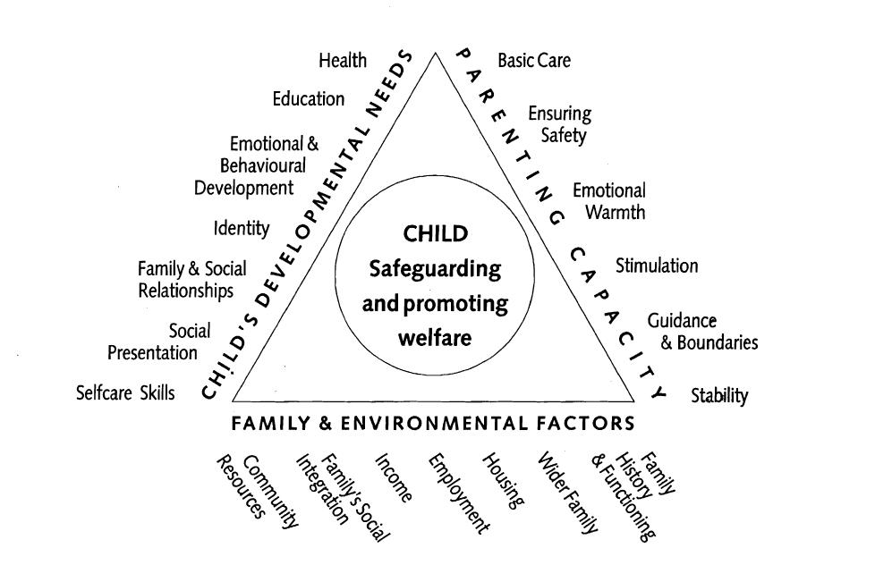

Working Together to Safeguard Children (DFE, 2015)

Physical abuse

Physical abuse may involve hitting, shaking, throwing, poisoning, burning or scalding, drowning, suffocating or otherwise causing physical harm to a child. Physical harm may

also be caused when a parent or carer fabricates the symptoms of, or deliberately induces, illness in a child.

 |  | Child
 |  | Bruises – shape, grouping, site, repeat or |  | Withdrawal from physical contact
 |  | multiple
 |  | Bite-marks – site and size |  | Aggression towards others, emotional and
 |  | Burns and Scalds – shape, definition, size, |  | behaviour problems
 |  | depth, scars
 |  | Improbable, conflicting explanations for |  | Frequently absent from school
 |  | injuries or unexplained injuries
 |  | Untreated injuries |  | Admission of punishment which appears
 |  |  |  | excessive
 |  | Injuries on parts of body where accidental |  | Fractures
 |  | injury is unlikely
 |  | Repeated or multiple injurie |  | Fabricated or induced illness -
 |  | Parent |  | Family/environment
 |  | Parent with injuries |  | History of mental health, alcohol or drug
 |  |  |  | misuse or domestic violence.
 |  | Evasive or aggressive towards child or others |  | Past history in the family of childhood abuse,
 |  |  |  | self-harm, somatising disorder or false
 |  |  |  | allegations of physical or sexual assault
 |  | Explanation inconsistent with injury |  | Marginalised or isolated by the community.
 |  | Fear of medical help / parents not seeking |  | Physical or sexual assault or a culture of
 |  | medical help |  | physical chastisement.
 |  | Over chastisement of child

Emotional abuse

The persistent emotional maltreatment of a child such as to cause severe and persistent

adverse effects on the child’s emotional development. It may involve conveying to a child that they are worthless or unloved, inadequate, or valued only insofar as they meet the needs of another person. It may include not giving the child opportunities to express their views, deliberately silencing them or ‘making fun’ of what they say or how they communicate. It may feature age or developmentally inappropriate expectations being imposed on children. These may include interactions that are beyond a child’s developmental capability, as well as

over protection and limitation of exploration and learning, or preventing the child participating in normal social interaction. It may involve seeing or hearing the ill-treatment of another. It may involve serious bullying (including cyber bullying), causing children frequently to feel frightened or in danger, or the exploitation or corruption of children. Some level of emotional abuse is involved in all types of maltreatment of a child, though it may occur alone.

 | Child
 | Self-harm | Over-reaction to mistakes / Inappropriate
 |  | emotional responses
 | Chronic running away | Abnormal or indiscriminate attachment
 | Drug/solvent abuse | Low self-esteem
 | Compulsive stealing | Extremes of passivity or aggression
 | Makes a disclosure | Social isolation – withdrawn, a ‘loner’ Frozen
 |  | watchfulness particularly pre school
 | Developmental delay | Depression
 | Neurotic behaviour (e.g. rocking, hair | Desperate attention-seeking behaviour
 | twisting, thumb sucking)
 | Parent | Family/environment
 | Observed to be aggressive towards child or | Marginalised or isolated by the community.
 | others
 | Intensely involved with their children, never | History of mental health, alcohol or drug
 | allowing anyone else to undertake their | misuse or domestic violence.
 | child's care.
 | Previous domestic violence | History of unexplained death, illness or
 |  | multiple surgery in parents and/or siblings of
 |  | the family
 | History of abuse or mental health problems | Past history in the care of childhood abuse,
 |  | self harm, somatising disorder or false
 |  | allegations of physical or sexual assault
 | Mental health, drug or alcohol difficulties | Wider parenting difficulties
 | Cold and unresponsive to the child’s | Physical or sexual assault or a culture of
 | emotional needs | physical chastisement.
 | Overly critical of the child | Lack of support from family or social
 |  | network.

Neglect

The persistent failure to meet a child’s basic physical and/or psychological needs, likely to result in the serious impairment of the child’s health or development. Neglect may occur during pregnancy as a result of maternal substance abuse. Once a child is born, neglect may involve a parent or carer failing to:

- provide adequate food, clothing and shelter (including exclusion from home or abandonment);

- protect a child from physical and emotional harm or danger;
- ensure adequate supervision (including the use of inadequate care-givers); or
- ensure access to appropriate medical care or treatment.

It may also include neglect of, or unresponsiveness to, a child’s basic emotional needs.

Child

Failure to thrive - underweight, small stature | Low self-esteem
Dirty and unkempt condition | Inadequate social skills and poor
 | socialisation
Inadequately clothed | Frequent lateness or non-attendance at
 | school
Dry sparse hair | Abnormal voracious appetite at school or
 | nursery
Untreated medical problems | Self-harming behaviour
Red/purple mottled skin, particularly on the | Constant tiredness
hands and feet, seen in the winter due to
cold
Swollen limbs with sores that are slow to | Disturbed peer relationships
heal, usually associated with cold injury
Parent | Family/environment
Failure to meet the child’s basic essential | Marginalised or isolated by the community.
needs including health needs
Leaving a child alone | History of mental health, alcohol or drug
 | misuse or domestic violence.
Failure to provide adequate caretakers | History of unexplained death, illness or
 | multiple surgery in parents and/or siblings of
 | the family
Keeping an unhygienic dangerous or | Past history in the family of childhood
hazardous home environment | abuse, self harm, somatising disorder or
 | false allegations of physical or sexual
 | assault
Unkempt presentation | Lack of opportunities for child to play and
 | learn
Unable to meet child’s emotional needs | Dangerous or hazardous home environment
 | including failure to use home safety
 | equipment; risk from animals
Mental health, alcohol or drug difficulties

Sexual abuse

Involves forcing or enticing a child or young person to take part in sexual activities, not necessarily involving a high level of violence, whether or not the child is aware of what is happening. The activities may involve physical contact, including assault by penetration (for example, rape or oral sex) or non-penetrative acts such as masturbation, kissing, rubbing and touching outside of clothing. They may also include non-contact activities, such as involving children in looking at, or in the production of, sexual images, watching sexual activities, encouraging children to behave in sexually inappropriate ways, or grooming a child in preparation for abuse (including via the internet). Sexual abuse is not solely perpetrated by adult males. Women can also commit acts of sexual abuse, as can other children.

Child
Self-harm - eating disorders, self-mutilation |  |  | Poor self-image, self-harm, self-hatred
and suicide attempts
Running away from home |  |  | Inappropriate sexualised conduct
Reluctant to undress for PE |  |  | Withdrawal, isolation or excessive worrying
Pregnancy |  |  | Sexual knowledge or behaviour
 |  |  | inappropriate to age/stage of development,
 |  |  | or that is unusually explicit
Inexplicable changes in behaviour, such as |  |  | Poor attention / concentration (world of their
becoming aggressive or withdrawn |  |  | own)
Pain, bleeding, bruising or itching in genital |  |  | Sudden changes in school work habits,
and /or anal area |  |  | become truant
Sexually exploited or indiscriminate choice
of sexual partners
 | Parent |  |  | Family/environment
 | History of sexual abuse |  |  | Marginalised or isolated by the community.
 | Excessively interested in the child. |  |  | History of mental health, alcohol or drug
 |  |  |  | misuse or domestic violence.
 | Parent displays inappropriate behaviour |  |  | History of unexplained death, illness or
 | towards the child or other children |  |  | multiple surgery in parents and/or siblings of
 |  |  |  | the family
 | Conviction for sexual offences |  |  | Past history in the care of childhood abuse,
 |  |  |  | self harm, somatising disorder or false
 |  |  |  | allegations of physical or sexual assault
 | Comments made by the parent/carer about |  |  | Grooming behaviour
 | the child.
 | Lack of sexual boundaries |  |  | Physical or sexual assault or a culture of
 |  |  |  | physical chastisement.

PHYSICAL ABUSE

Physical abuse may involve hitting, shaking, throwing, poisoning, burning or scalding, drowning, suffocating, or otherwise causing physical harm to a child. Physical harm may also be caused when a parent or carer fabricates the symptoms of, or deliberately induces, illness in a child.

Indicators in the child

Bruising

It is often possible to differentiate between accidental and inflicted bruises. The following must be considered as non accidental unless there is evidence or an adequate explanation provided:
Bruising in or around the mouth

Two simultaneous bruised eyes, without bruising to the forehead, (rarely accidental, though a single bruised eye can be accidental or abusive)

Repeated or multiple bruising on the head or on sites unlikely to be injured accidentally, for

example the back, mouth, cheek, ear, stomach, chest, under the arm, neck, genital and rectal areas
Variation in colour possibly indicating injuries caused at different times The outline of an object used e.g. belt marks, hand prints or a hair brush Linear bruising at any site, particularly on the buttocks, back or face

Bruising or tears around, or behind, the earlobe/s indicating injury by pulling or twisting Bruising around the face

Grasp marks to the upper arms, forearms or leg

Petechae haemorrhages (pinpoint blood spots under the skin.) Commonly associated with

slapping, smothering/suffocation, strangling and squeezing

Fractures

Fractures may cause pain, swelling and discolouration over a bone or joint. It is unlikely that a
child will have had a fracture without the carers being aware of the child's distress.

If the child is not using a limb, has pain on movement and/or swelling of the limb, there may be a fracture.

There are grounds for concern if:

The history provided is vague, non-existent or inconsistent There are associated old fractures

Medical attention is sought after a period of delay when the fracture has caused symptoms such as swelling, pain or loss of movement

Rib fractures are only caused in major trauma such as in a road traffic accident, a severe shaking injury or a direct injury such as a kick.

Skull fractures are uncommon in ordinary falls, i.e. from three feet or less. The injury is usually witnessed, the child will cry and if there is a fracture, there is likely to be swelling on the skull developing over 2 to 3 hours. All fractures of the skull should be taken seriously.

Mouth Injuries

Tears to the frenulum (tissue attaching upper lip to gum) often indicates force feeding of a baby or a child with a disability. There is often finger bruising to the cheeks and around the mouth. Rarely, there may also be grazing on the palate.

Poisoning

Ingestion of tablets or domestic poisoning in children under 5 is usually due to the carelessness of a parent or carer, but it may be self harm even in young children.

Fabricated or Induced Illness

Professionals may be concerned at the possibility of a child suffering significant harm as a result of having illness fabricated or induced by their carer. Possible concerns are:
Discrepancies between reported and observed medical conditions, such as the incidence of

fits

Attendance at various hospitals, in different geographical areas

Development of feeding / eating disorders, as a result of unpleasant feeding interactions The child developing abnormal attitudes to their own health

Non organic failure to thrive - a child does not put on weight and grow and there is no underlying medical cause

Speech, language or motor developmental delays Dislike of close physical contact

Attachment disorders Low self esteem
Poor quality or no relationships with peers because social interactions are restricted Poor attendance at school and under-achievement

Bite Marks

Bite marks can leave clear impressions of the teeth when seen shortly after the injury has been inflicted. The shape then becomes a more defused ring bruise or oval or crescent shaped. Those over 3cm in diameter are more likely to have been caused by an adult or older child.

A medical/dental opinion, preferably within the first 24 hours, should be sought where there is any doubt over the origin of the bite.

Burns and Scalds

It can be difficult to distinguish between accidental and non-accidental burns and scalds. Scalds are the most common intentional burn injury recorded.

Any burn with a clear outline may be suspicious e.g. circular burns from cigarettes, linear burns from hot metal rods or electrical fire elements, burns of uniform depth over a large area, scalds that have a line indicating immersion or poured liquid.

Old scars indicating previous burns/scalds which did not have appropriate treatment or adequate explanation. Scalds to the buttocks of a child, particularly in the absence of burns to the feet, are indicative of dipping into a hot liquid or bath.

The following points are also worth remembering:

A responsible adult checks the temperature of the bath before the child gets in.

A child is unlikely to sit down voluntarily in a hot bath and cannot accidentally scald its

bottom without also scalding his or her feet.

A child getting into too hot water of his or her own accord will struggle to get but and there will be splash marks

Scars

A large number of scars or scars of different sizes or ages, or on different parts of the body, or unusually shaped, may suggest abuse.

Emotional/behavioural presentation

Refusal to discuss injuries

Admission of punishment which appears excessive

Fear of parents being contacted and fear of returning home

Withdrawal from physical contact

Arms and legs kept covered in hot weather

Fear of medical help

Aggression towards others

Frequently absent from school

An explanation which is inconsistent with an injury

Several different explanations provided for an injury

Indicators in the parent

May have injuries themselves that suggest domestic violence

Not seeking medical help/unexplained delay in seeking treatment

Reluctant to give information or mention previous injuries

Absent without good reason when their child is presented for treatment

Disinterested or undisturbed by accident or injury

Aggressive towards child or others

Unauthorised attempts to administer medication

Tries to draw the child into their own illness.

Past history of childhood abuse, self harm, somatising disorder or false allegations of physical or sexual assault

Parent/carer may be over involved in participating in medical tests, taking temperatures and measuring bodily fluids

Observed to be intensely involved with their children, never taking a much needed break nor allowing anyone else to undertake their child's care.

May appear unusually concerned about the results of investigations which may indicate physical illness in the child

Wider parenting difficulties may (or may not) be associated with this form of abuse.

Parent/carer has convictions for violent crimes.

Indicators in the family/environment

Marginalised or isolated by the community

History of mental heath, alcohol or drug misuse or domestic violence

History of unexplained death, illness or multiple surgery in parents and/or siblings of the family

Past history of childhood abuse, self harm, somatising disorder or false allegations of physical or sexual assault or a culture of physical chastisement.

EMOTIONAL ABUSE

Emotional abuse is the persistent emotional maltreatment of a child such as to cause severe and persistent adverse effects on the child’s emotional development. It may involve conveying to children that they are worthless or unloved, inadequate, or valued only insofar as they meet the needs of another person.

It may include not giving the child opportunities to express their views, deliberately silencing them or ‘making fun’ of what they say or how they communicate.

It may feature age or developmentally inappropriate expectations being imposed on children. These may include interactions that are beyond the child’s developmental capability, as well as overprotection and limitation of exploration and learning, or preventing the child participating in normal social interaction.

It may involve seeing or hearing the ill-treatment of another. It may involve serious bullying (including cyberbullying), causing children frequently to feel frightened or in danger, or the exploitation or corruption of children.

Some level of emotional abuse is involved in all types of maltreatment of a child, though it may occur alone.

Indicators in the child

Developmental delay

Abnormal attachment between a child and parent/carer e.g. anxious, indiscriminate or no attachment

Aggressive behaviour towards others
Child scapegoated within the family

Frozen watchfulness, particularly in pre-school children Low self esteem and lack of confidence

Withdrawn or seen as a 'loner' - difficulty relating to others

Over-reaction to mistakes

Fear of new situations

Inappropriate emotional responses to painful situations

Neurotic behaviour (e.g. rocking, hair twisting, thumb sucking)

Self harm

Fear of parents being contacted

Extremes of passivity or aggression

Drug/solvent abuse

Chronic running away

Compulsive stealing

Low self-esteem

Air of detachment – ‘don’t care’ attitude

Social isolation – does not join in and has few friends Depression, withdrawal

Behavioural problems e.g. aggression, attention seeking, hyperactivity, poor attention

Low self esteem, lack of confidence, fearful, distressed, anxious

Poor peer relationships including withdrawn or isolated behaviour

Indicators in the parent

Domestic abuse, adult mental health problems and parental substance misuse may be features in families where children are exposed to abuse.

Abnormal attachment to child e.g. overly anxious or disinterest in the child Scapegoats one child in the family

Imposes inappropriate expectations on the child e.g. prevents the child’s developmental exploration or learning, or normal social interaction through overprotection.

Wider parenting difficulties may (or may not) be associated with this form of abuse.

Indicators of in the family/environment

Lack of support from family or social network.

Marginalised or isolated by the community.

History of mental heath, alcohol or drug misuse or domestic violence.

History of unexplained death, illness or multiple surgery in parents and/or siblings of the family Past history of childhood abuse, self harm, somatising disorder or false allegations of physical or sexual assault or a culture of physical chastisement.

NEGLECT

Neglect is the persistent failure to meet a child’s basic physical and/or psychological needs, likely to result in the serious impairment of the child’s

health or development. Neglect may occur during pregnancy as a result of maternal substance abuse.

Once a child is born, neglect may involve a parent or carer failing to:

- provide adequate food, clothing and shelter (including exclusion from home or abandonment);

- protect a child from physical and emotional harm or danger;

- ensure adequate supervision (including the use of inadequate care-givers); or

- ensure access to appropriate medical care or treatment.

It may also include neglect of, or unresponsiveness to, a child’s basic emotional needs.

Indicators in the child

Physical presentation

Failure to thrive or, in older children, short stature

Underweight

Frequent hunger

Dirty, unkempt condition

Inadequately clothed, clothing in a poor state of repair

Red/purple mottled skin, particularly on the hands and feet, seen in the winter due to cold

Swollen limbs with sores that are slow to heal, usually associated with cold injury

Abnormal voracious appetite

Dry, sparse hair

Recurrent / untreated infections or skin conditions e.g. severe nappy rash, eczema or persistent head lice / scabies/ diarrhoea

Unmanaged / untreated health / medical conditions including poor dental health Frequent accidents or injuries

Development

General delay, especially speech and language delay

Inadequate social skills and poor socialization

Emotional/behavioural presentation

Attachment disorders

Absence of normal social responsiveness

Indiscriminate behaviour in relationships with adults

Emotionally needy

Compulsive stealing

Constant tiredness

Frequently absent or late at school

Poor self esteem

Destructive tendencies

Thrives away from home environment

Aggressive and impulsive behaviour

Disturbed peer relationships

Self harming behaviour

Indicators in the parent
Dirty, unkempt presentation

Inadequately clothed

Inadequate social skills and poor socialisation

Abnormal attachment to the child .e.g. anxious

Low self esteem and lack of confidence

Failure to meet the basic essential needs e.g. adequate food, clothes, warmth, hygiene

Failure to meet the child’s health and medical needs e.g. poor dental health; failure to attend or keep appointments with health visitor, GP or hospital; lack of GP registration; failure to seek or comply with appropriate medical treatment; failure to address parental substance misuse during pregnancy

Child left with adults who are intoxicated or violent Child abandoned or left alone for excessive periods

Wider parenting difficulties, may (or may not) be associated with this form of abuse

Indicators in the family/environment

History of neglect in the family

Family marginalised or isolated by the community.

Family has history of mental heath, alcohol or drug misuse or domestic violence.

History of unexplained death, illness or multiple surgery in parents and/or siblings of the family Family has a past history of childhood abuse, self harm, somatising disorder or false allegations of physical or sexual assault or a culture of physical chastisement.

Dangerous or hazardous home environment including failure to use home safety equipment; risk from animals

Poor state of home environment e.g. unhygienic facilities, lack of appropriate sleeping arrangements, inadequate ventilation (including passive smoking) and lack of adequate heating Lack of opportunities for child to play and learn

SEXUAL ABUSE

Sexual abuse involves forcing or enticing a child or young person to take part in sexual activities, not necessarily involving a high level of violence, whether or not the child is aware of what is happening.

The activities may involve physical contact, including assault by penetration (for example, rape or oral sex) or non-penetrative acts such as masturbation, kissing, rubbing and touching outside of clothing.

They may also include non-contact activities, such as involving children in looking at, or in the production of, sexual images, watching sexual activities, encouraging children to behave in sexually inappropriate ways, or grooming a child in preparation for abuse (including via the internet).

Sexual abuse is not solely perpetrated by adult males. Women can also commit acts of sexual abuse, as can other children.

Indicators in the child

Physical presentation

Urinary infections, bleeding or soreness in the genital or anal areas

Recurrent pain on passing urine or faeces

Blood on underclothes

Sexually transmitted infections

Vaginal soreness or bleeding

Pregnancy in a younger girl where the identity of the father is not disclosed and/or there is secrecy or vagueness about the identity of the father

Physical symptoms such as injuries to the genital or anal area, bruising to buttocks, abdomen and thighs, sexually transmitted disease, presence of semen on vagina, anus, external genitalia or clothing

Emotional/behavioural presentation

Makes a disclosure.

Demonstrates sexual knowledge or behaviour inappropriate to age/stage of development, or that is unusually explicit

Inexplicable changes in behaviour, such as becoming aggressive or withdrawn

Self-harm - eating disorders, self mutilation and suicide attempts

Poor self-image, self-harm, self-hatred

Reluctant to undress for PE

Running away from home

Poor attention / concentration (world of their own)

Sudden changes in school work habits, become truant

Withdrawal, isolation or excessive worrying

Inappropriate sexualised conduct

Sexually exploited or indiscriminate choice of sexual partners

Wetting or other regressive behaviours e.g. thumb sucking

Draws sexually explicit pictures

Depression

Indicators in the parents

Comments made by the parent/carer about the child.

Lack of sexual boundaries

Wider parenting difficulties or vulnerabilities

Grooming behaviour

Parent is a sex offender

Indicators in the family/environment

Marginalised or isolated by the community.

History of mental heath, alcohol or drug misuse or domestic violence.

History of unexplained death, illness or multiple surgery in parents and/or siblings of the family

Past history of childhood abuse, self harm, somatising disorder or false allegations of physic or Child sexual exploitation (CSE) involves exploitative situations, contexts and relationships where young people receive something (for example food, accommodation, drugs, alcohol, gifts, money or in some cases simply affection) as a result of engaging in sexual activities. Sexual exploitation can take many forms ranging from the seemingly ‘consensual’ relationship where sex is exchanged for affection or gifts, to serious

organised crime by gangs and groups. What marks out exploitation is an imbalance of power in the relationship. The perpetrator always holds some kind of power over the victim which increases as the exploitative relationship develops. Sexual exploitation involves varying degrees of coercion, intimidation or enticement, including unwanted pressure from peers to have sex, sexual bullying including cyberbullying and grooming.

However, it also important to recognise that some young people who are being sexually exploited do not exhibit any external signs of this abuse.

sexual assault or a culture of physical chastisement. Family member is a sex offender.

Appendix 2

FOR INFORMATION ONLY. REVISED GUIDANCE WILL COMMENCE 3 SEPTEMBER 2018. UNTIL THAT POINT SCHOOLS AND COLLEGES MUST CONTINUE TO HAVE REGARD TO THE 2016 KCSIE

Female Genital Mutilation (FGM): professionals in all agencies, and individuals and groups in relevant communities, need to be alert to the possibility of a girl being at risk of FGM, or already having suffered FGM. There is a range of potential indicators that a child or young person may be at risk of FGM, which individually may not indicate risk but if there are two or more indicators present this could signal a risk to the child or young person. Victims of FGM are likely to come from a community that is known to practice FGM. Professionals should note that girls at risk of FGM may not yet be aware of the practice or that it may be conducted on them, so sensitivity should always be shown when approaching the subject. Warning signs that FGM may be about to take place, or may have already taken place, can be found on pages 11-12 of the Multi-Agency

Practice Guidelines referred to previously. Staff should activate local safeguarding procedures, using existing national and local protocols for multi-agency liaison with police

THERE IS A STATUTORY DUTY ON ALL STAFF TO INFORM THE POLICE STAIGHT AWAY IF FGM IS SUSPECTED

APPENDIX 3: WHAT TO DO IF YOU ARE WORRIED A CHILD IS BEING ABUSED: ADVICE FOR PRACTITIONERS (DfE 2015) Flowchart
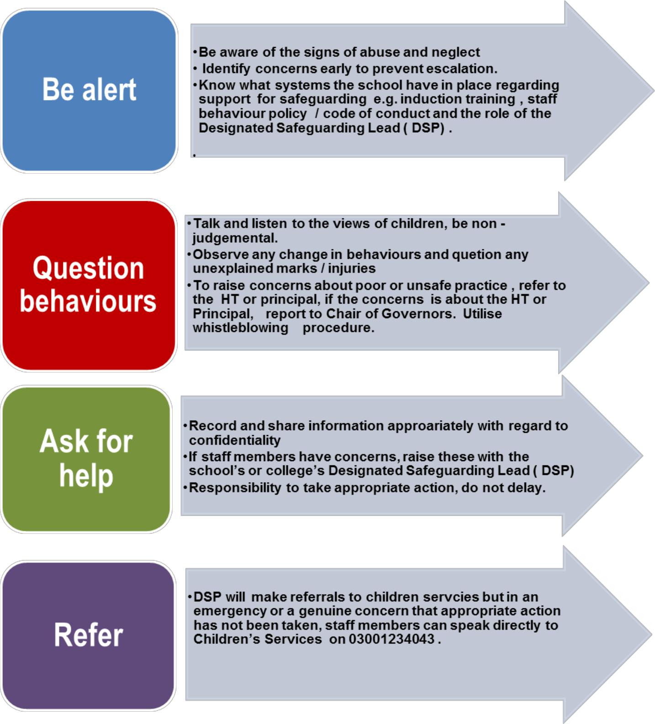

Appendix 3
Safeguarding and ICT

Protecting young people in the online world means thinking beyond the school environment. As well as the computer to access the Internet, now many mobile phones and games consoles offer broadband connections. Pupils may be working online in school, at home or in an Internet café. Increasingly pupils will have access to personal devices not covered by network protection and therefore the emphasis needs to be on educating all users as to the risks involved and their obligation to act responsibly while online.

Safeguarding pupils in both the real and virtual world is everyone’s responsibility and all staff should be aware of this policy and how to respond to e-safety incidents.

All pupils should be made aware of the school’s Acceptable Use Policy (AUP) and what to do if they have any ICT safeguarding concerns. Harassment, grooming of another person using technology, breaching their right to privacy, poses a serious threat to physical and emotional safety, and may have legal consequences.

Teaching about online safety :

- Children should be taught about online safety. It is not the responsibility of the computing curriculum but should be woven into the whole curriculum. It should start with early years and develop throughout the year, across all age groups and all subject areas; All subject teachers to identify topics where this can be included in the schemes of work

- xxxx will consider how to target children who may require more specific educational approaches to enable them to build online safety skills.

Best practice

- We recommend that all staff members consider how online safety can be taught within their own curriculum or subject and that learners have an input into their online safety curriculum.

- All staff are given the online safety policy, procedures and acceptable use policy at induction. Responsibility for online safety

- The ultimate responsibility for online safety falls within the remit of the Designated Safeguarding Lead (DSL) as online safety is a safeguarding issue. xxxxx delegates some of the activities regarding online safety to ICT lead teacher, due to individual knowledge and experience, especially regarding curriculum content or specific technical knowledge and skills. However, as

30

online safety is clearly identified as a safeguarding priority the ultimate responsibility lies with the DSL.

- ICT Staff with appropriate skills, interest and expertise regarding online safety will help support the DSL(s) as appropriate, for example when developing curriculum approaches or making technical decisions.

Procedures for dealing with Inappropriate / Illegal Internet Access or Material

If staff or pupils discover unsuitable websites, this should be immediately reported to the CPO who, in liaison with the ICT manager for the school, will consider a referral to the Internet Watch Foundation (IWF) and the Police. Illegal material within the school’s network is a very serious situation and must always be reported to the Police. Our school ensures processes are in place to minimise the risk of students gaining access to inappropriate materials, through supervision and monitoring. Any incident that involves inappropriate adult access to legal material on the school premises will be dealt with by the school’s disciplinary policy.

In the event of discovery of illegal material seek immediate and specific advice from the CPO who will consult with the ICT Manager, the Headmaster and the Police.

Combating Cyber-bullying

Cyberbullying is a form of bullying and can be defined as 'the use of Information and Communications Technology (ICT), particularly mobile phones and the internet, deliberately and over a period of time, to upset someone else'. It can be an extension of face-to-face bullying, with technology providing the bully with another route to harass their target. However, it differs in several significant ways from other kinds of bullying: the invasion of home and personal space; the difficulty in controlling electronically circulated messages, the size of the audience, perceived anonymity, and even the profile of the person doing the bullying and their target. The School Rules and Regulations state that “misconduct of any kind outside of School will be amenable to School discipline if the welfare of another pupil or the culture or reputation of the School are placed at risk.” Our role with regards to Bullying and Cyberbullying can extend therefore beyond the “School gates” and may include times when pupils are not under the control or charge of a member of staff.

Cyberbullying takes different forms: threats and intimidation, harassment or 'cyber-stalking' (eg repeatedly sending unwanted texts or instant messages), vilification / defamation; exclusion or peer rejection, impersonation, unauthorized publication of private information or images and manipulation.

31

Some cyberbullying is clearly deliberate and aggressive, but it is important to recognise that some incidents of cyberbullying are known to be unintentional and the result of simply not thinking about the consequences. What may be sent as a joke may not be received as one, and indeed the distance that technology allows in communication means the sender may not see the impact of the message on the receiver. There is also less opportunity for either party to resolve any misunderstanding or to feel empathy. It is important that pupils are made aware of the effects of their actions.

In cyberbullying, bystanders can easily become perpetrators, e.g. by passing on or showing to others images designed to humiliate, or by taking part in online polls or discussion groups. They may not recognise themselves as participating in bullying, but their involvement compounds the misery for the person targeted. Our policy is clear: 'bystanders' — better termed 'accessories' in this context — who actively support cyberbullying should expect a sanction for this behaviour. It is important that pupils are aware that their actions have severe and distressing consequences, and that participating in such activity will not be tolerated.

There are particular features of cyberbullying that differ from other forms of bullying which need to be recognised and taken into account when determining how to respond effectively. The key differences are:

Impact — the scale and scope of cyberbullying can be greater than other forms of bullying.

Targets and perpetrators — the people involved may have a different profile to

traditional bullies and their targets.
Location — the 24/7 and any-place nature of cyberbullying.

Anonymity — the person being bullied will not always know who is attacking them. Motivation — some pupils may not be aware that what they are doing is bullying.

Evidence — unlike other forms of bullying, the target of the bullying will have evidence of its occurrence.

Prevention

We seek to instil values in all members of the School which should, preclude bullying. These are reinforced by a PSHE programme which requires tutors at all levels of the School to spend time talking to their groups about cyberbullying and its effects and consequences. In essence, these seek to inculcate respect for others, their property and their individuality. The above values should not only be addressed in PSHE but should also underpin ordinary curricular lessons, assemblies, Horizons Lectures, tutorials, debates, the co-curricular programme and chapel services.

It is crucial to the School’s success in dealing with cyberbullying that all members of the community are made aware that it is unacceptable and should not be tolerated. It is the responsibility of all members of the community to take action if they are aware of it happening. To remain silent is to condone the action of the bully. Staff should receive regular training and guidance in order to reduce the risk of bullying arising particularly at times or in areas where it is most likely. If necessary, external agencies will be consulted if specialist skills may be required.

Procedure

- Information about bullying comes from a variety of sources, including parents, pupils, staff and members of the public. In all cases we assure the person making the allegation that we

32

shall be taking immediate action to stop the bullying / cyberbullying and will pursue information so as to identify the bully. Parents are informed as soon as possible, though sometimes some leeway may be required in order for investigations to be completed.

- Depending on the nature of the allegation, the case will be taken up either by the tutor, house staff, a deputy head or a combination of these people. As a rough guide, the more serious the allegation, the more likely it is to involve senior staff. If there is a Child Protection implication, i.e. if there is reasonable cause to suspect that a child is suffering, or likely to suffer significant harm then the Child Protection Officer must be informed.

- Interviews will be conducted fairly, giving all sides the opportunity to state their case, so as to establish the truth in what seldom turn out to be straightforward issues. In all cases, pupils will be warned not to do or say anything that may prejudice their position vis-à-vis the pupil who has been bullied. (No revenge / stirring up support among friends, no taking the law into their own hands.)

- Except for the most straightforward cases, in which truth has been established and the matter has been resolved swiftly, an interview will be conducted; a pupil would be invited to bring a friend or member of staff to support them in any such interview. This will enable a record to be kept of the interview and what is said to be corroborated. Notes, both rough copies and, where necessary, a brief summary and copies of any letters sent to parents will be put on files with cross referencing where appropriate. Notes will be retained by the Deputy Head which will enable patterns to be identified.

- Letters written to parents will detail the nature of the offence and any sanctions imposed, and will set out what improvements the School expects to be made in behaviour as well as the consequences of failure to improve. Recommendations may be made about visits to the Health Centre and counselling for everyone involved.

- At the conclusion of the investigation, if appropriate, one of the members of staff involved will contact parents of all pupils directly involved and inform them of action taken. Wherever possible, the identity of “informers” and pupils other than the son or daughter of the parent will not be disclosed.

- In practice, the sanctions applied range from a verbal warning or a ban on use of the School’s computer network, to temporary or permanent exclusion, depending on the gravity of the offence and the pupil’s previous record with reference to bullying.

Sanctions for Cyberbullying Behaviour

In practice, the sanctions applied range from a verbal warning or a ban on use of the School’s computer network to a temporary or permanent exclusion, depending on the gravity of the offence and the pupil’s previous record with reference to bullying / cyber-bullying. In the most severe cases, it can result in criminal prosecution.

The aim of sanctions is to:

Help the person harmed to feel safe again and be assured that the bullying will stop.

Hold the perpetrator to account getting them to recognise the harm caused and deter them from repeating the behaviour.

33

Demonstrate to the school community that cyberbullying is unacceptable and that the school has effective ways of dealing with it, so deterring others from behaving similarly.

When cyberbullying is investigated, reference will be made to the Acceptable Use Policy (AUP); sanctions for breaches are set out in the AUP and the ‘Procedure for dealing with Bullying / Cyberbullying incidents’. Technology-specific sanctions for pupils engaged in cyberbullying behaviour could include limiting internet access for a period of time or removing the right to bring a mobile phone into school (although issues of child safety will be considered in relation to the latter).

Cyberbullying will have an impact on the education and wellbeing of the person being bullied, and the physical location of the bully at the time of their action is irrelevant in this. Schools have broad powers to discipline and regulate the behaviour of pupils, even when they are off the school site. Misconduct of any kind outside of school will be amenable to school discipline if the welfare of another pupil or the culture or reputation of the school are placed at risk.

Anti-Cyber-bullying Code: Advice to pupils

Being sent an abusive or threatening text message, or seeing nasty comments about yourself on a website, can be really upsetting. This code gives you seven important tips to protect yourself and your friends from getting caught up in cyber-bullying, and advice on to how to report it when it does happen.

1. Always respect others

Remember that when you send a message to someone, you cannot see the impact that your words or images may have on the other person. That is why it is important to always show respect to people and be careful what you say online or what images you send. What you think is a joke may really hurt someone else. Always ask permission before you take a photo of someone.

If you receive a rude or nasty message or picture about someone else, do not forward it. You could be assisting a bully and even be accused of cyber-bullying yourself. You could also be breaking the law.

2. Think before you send

It is important to think before you send any images or text about yourself or someone else by email or mobile phone, or before you post information on a website. Remember that what you send can be made public very quickly and could stay online forever. Do you really want your teacher, parents or future employer to see that photo?

3. Treat your password like your toothbrush

Don't let anyone know your passwords. It is a good idea to change them on a regular basis. Choosing hard-to-guess passwords with symbols or numbers will help stop people hacking into your account and pretending to be you. Remember to only give your mobile number or personal website address to trusted friends.

4. Block the Bully

Most responsible websites and services allow you to block or report someone who is behaving badly. Make use of these features, they are there for a reason!

34

5. Don't retaliate or reply

Replying to bullying messages, particularly in anger, is just what the bully wants.

6. Save the evidence

Learn how to keep records of offending messages, pictures or online conversations. These will help you demonstrate to others what is happening and can be used by your school, internet service provider, mobile phone company, or even the police to investigate the cyber-bullying.

7. Make sure you tell

You have a right not to be harassed and bullied online.

There are people that can help:

Tell an adult you trust who can help you to report it to the right place, or call a helpline like ChildLine on 0800 1111 in confidence.

Tell the provider of the service you have been bullied on (eg your mobile-phone operator or social-network provider). Check their websites to see where to report.

Tell your school. Your tutor, Housemaster / Housemistress or any member of staff will support you and can discipline the person bullying you.

Finally, don't just stand there. If you see cyber-bullying going on, support the victim and report the bullying. How would you feel if no one stood up for you?

35

APPENDIX 4

Safety & Support Plan

for children / young people in education
(STRICTLY CONFIDENTIAL)

Risk is defined as ‘uncertain prediction about future behaviour with a chance that the future outcome of the behaviour will be harmful or negative’ (Kemshall, 1996)

Name of child / young person:

Date of birth:

Ethnicity:

Name of education setting:

Form:

Date:

Terms of reference

The safety and support plan is not a legal document and the process is not adversarial, it is a VOLUNTARY tool that the school can use to engage a child and their parents to identify any
concerns

and agree on support strategies that can be put in place to minimise any potential risk to a child / Young person.

The aim is to ensure that a child / young person has the opportunity to express their wishes and Feelings and be enabled to voice how they may be assisted to feel supported and safe in their education environment.

The development, implementation and review of this document are the responsibility of the school.

The Safety and support plan can be considered for children / young people in circumstances who:

Present a risk either to themselves or others due to their circumstances and the nature of their behaviour and actions towards themselves and others or they could be exposed / subject to the adverse behaviours and actions of children in the school setting who may be affected by the following factors (these are examples and not a complete list, staff will need to seek appropriate advice and/or use professional judgement about circumstances in which this tool should be used):
- low level non safeguarding sexualised behaviour

- physical and verbal aggression

- bullying

- emotional and behaviour difficulties

- young people who are sexually active or could be at risk of child sexual exploitation

- vulnerabilities associated with children whom have a disability or special educational needs

- If there is a known or potential risk by an adult in the community e.g. court orders preventing contact with a particular individual, (advice should be sought as to whether a Risk Assessment Management Plan or this document are appropriate)

This document is not an assessment for children / young people who have disclosed that they have suffered significant harm or you suspect are at risk of harm – in these circumstances this would meet the threshold for safeguarding specialist services (child protection) therefore:

Please contact or make a referral to Children Services

Once the need for a Safety and Support Plan has been identified, the process should run as follows:

- DSP to discuss / meet with child, parents / carer to discuss and establish if a plan is required. As part of this discussion consideration given to any other key professionals / resources to be involved in the support plan.

- School to prepare a draft based on the discussion with, parent / carer, child and
other agencies / resources if relevant.

- Safety and support plan to be confidentially shared and finalised with child and parents/s, this should include all parties signing the document as part of the agreement to comply with the support strategies that will be implemented.

- All participants to confidentially receive a signed copy.
- School to use chronology to monitor and record for review of this plan.
- Date set to review the plan.
- You will need:

- The Safety and Support Plan proforma

- Appendix one – Evaluation of the school environment
Context of concerns✓ / behaviour - what has happened and why is plan needed?
Appendix two – Chronology see Appendix Two

Use pointers below to support your thinking

- Describe the type of behaviours, context of behaviour- was it spontaneous or planned? Was there force/ threat etc?

- When and Where? ( date)

- Summary of what has happened

Identification of the concerns and any risks?
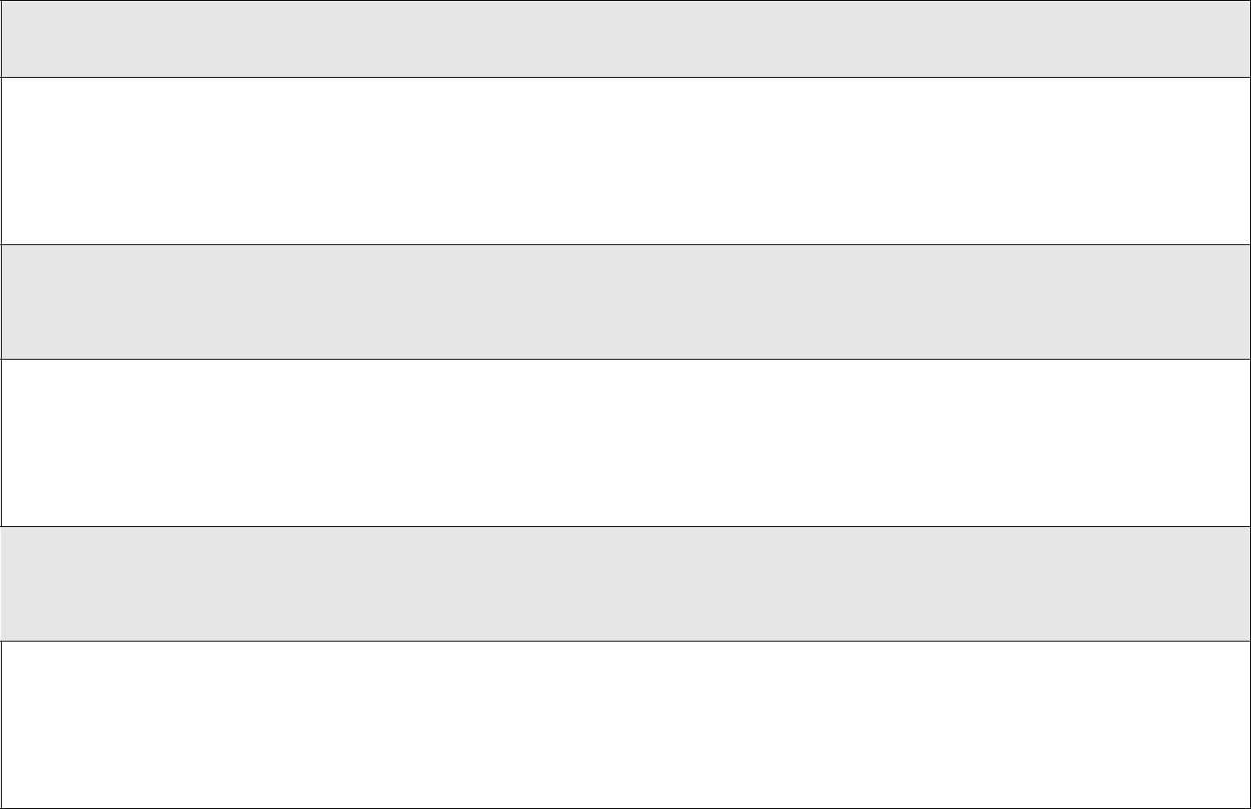

What are the concerns /risks?
List or bullet point.

In which situations could this occur?

E.g. physical environment of your setting, unstructured times, transition times, to and from class / school et. SEE APPENDIX ONE – Evaluation of school environment checklist.

Who could be affected and what harm could be sustained?

e.g. this is about the risk / harm or adverse effects that the subject could place on themselves, because of their behaviour, or place on others e.g. emotional, physical, sexual or neglect.

What heightens the concerns or risk?

Think about potential negative factors in the school and community that could increase any adverse reaction/risk

What lowers the concerns or risk? Think about what protective and positive factors child has in the school and community that can help reduce any adverse reaction / risk

Child’s response/ view of the concerns raised?

View of the child / young person, do they support and agree that this plan will assist them?

Parent / carer’s view?

Views of the child’s parents in relation to this do they support / agree to this plan?

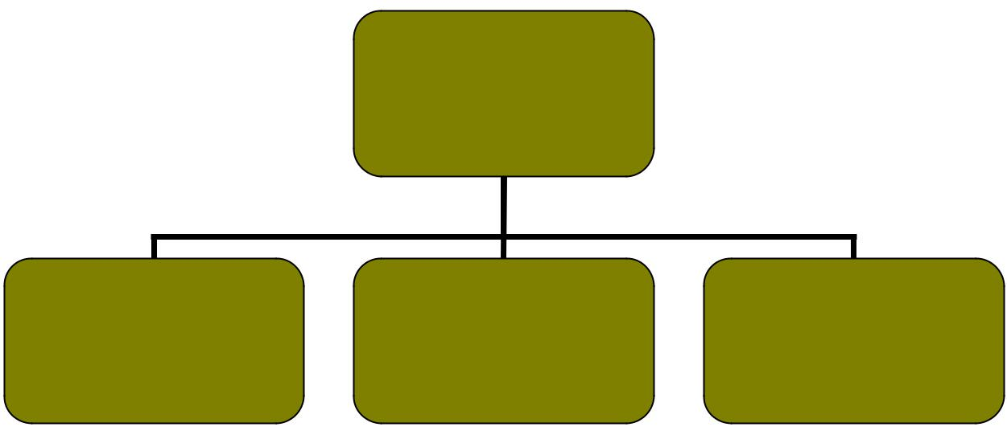
Safety and
Support Plan

Child / young
person

Response to

further incident / Review concerns

 | Support strategies / measures to be put into place |  |  | Who/When?
 | Liaison with parents:
 | Who is doing this and how often?
 | ( write response below)
 | Liaison with child / young person:
 | Who is the young persons point of contact should they need to express their
 | wishes – who would be available if that staff member is not in school?
 | The right to be safe:
 | What messages have been given about the right to be safe, how can this be
 | reinforced? How safe does the child feel?
 | School environment:
 | Is it likely that the cause of concerns means that the child / YP will be in the same

area of the school? If there is a joint friendship group? How will the need for no contact be managed if necessary? Do changes need to be made? School Environment for supporting your planning.

Individual support:

What access to support has the child / young person been offered? Is there an identified programme of work? If so what is it and who is delivering this? (E.g. If the child is feeling angry – how would they be able to leave the class without questions being asked?)

Family support:

Are the family being offered any support? Do they need any? Are there any services that the school can signpost them to?

Information Sharing:

If time out of lessons is needed (for interviews, social work visits etc), how will the school support the child with an explanation to friendship groups?

Monitoring:

What are the monitoring arrangements for this pupil to ensure that future risks are minimized? SEE APPENDIX TWO - CHRONOLOGY.

Date and venue for, Safety & Support Plan to be REVIEWED?

Immediate response to further incident /concerns

Immediate response / interventions to incident or further concerns:

Action to be taken immediately if an incident or further concern arises. What is the school to do, the child / YP and what will parents / carers do? You can bullet point your range of responses in order.

Consent and Agreement of Safety and Support Plan

Name | Role | Signature
 | Head Teacher / Principal
 | Designated Senior Person
 | ( DSP)
 | Form Tutor
 | Other relevant school staff
 | Support staff
 | Child Protection Schools
 | Liaison Officer
 | Please note it is optional if
 | CPSLO is contacted by school re
 | this NON statutory plan.
 | Child/young person
 | Parent/carer
 | Other Agencies or other
 | significant resources

Review of Safety & Support Plan

Actions/amendments |  |  |  | By who and by
Using the Safety and Support Plan and the Chronology re any Incidences, evaluate whether |  |  |  | when by?
any changes need to be made to the Safety and Support Plan? A review will consider any
new information, change in circumstances and any work carried out with the child and
family by school or other agencies / universal resources e.g. GP. Include positive outcomes.
List below:

APPENDIX 5

xxxx

Appendix 5: Draft Recording Form for Safeguarding Concerns

Staff, volunteers and regular visitors are required to complete this form and pass it to xxxxx if they have a safeguarding concern about a child in our school.

Full name of child | Date of Birth | Tutor/Form group | Your name and position
 |  |  | in school

Nature of concern/disclosure

Please include where you were when the child made a disclosure, what you saw, who else was there, what did the child say or do and what you said.

Was there an injury? Yes / No | Did you see it? Yes / No
Describe the injury:

Have you filled in a body plan to show where the injury is and its approximate size? Yes / No

Was anyone else with you? Who?

Has this happened before? | Did you report the previous incident?
Who are you passing this information to? Name: |  | Date:
 | Position: | Time:

Your signature:

Date:

□

Action taken by SDP

Referred to…?

Attendance
Improvement
Officer |  | Police |  | School Nurse |  |  | Children’s |  |  | Integrated |  |  | Parents |  |  | Other
 |  |  |  |  |  |  | Services |  |  | Youth Service

Parents informed? Yes / No (If No, state reason) Feedback given to…?

Body Map

 | Tutor
Pastoral team |  | Student

Person who recorded

Full name:

SDP Signature:

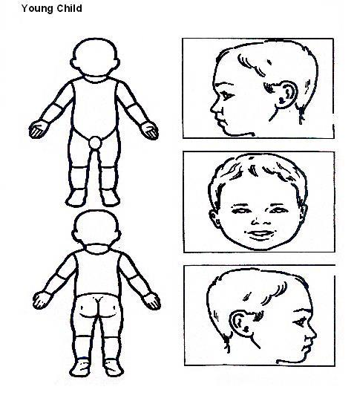

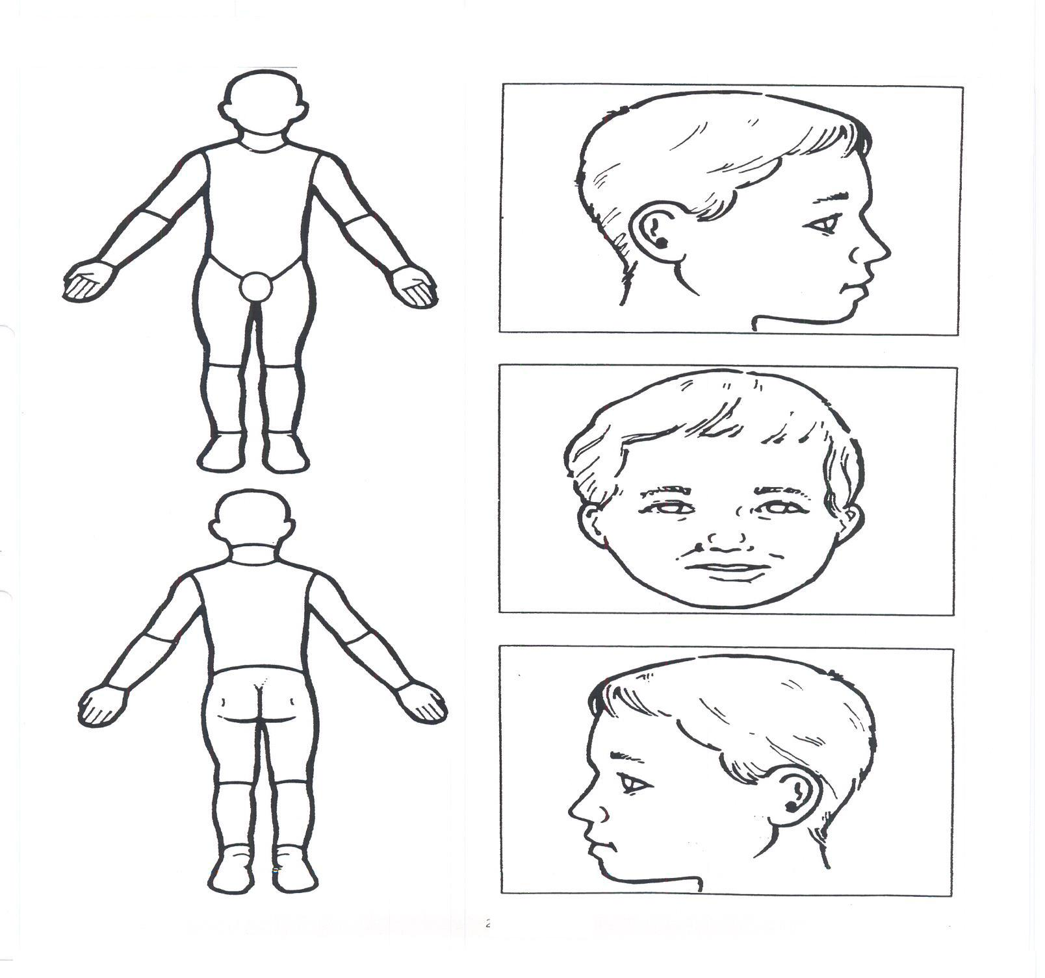
Older Child

XXXXX

Appendix 6: Safeguarding Induction Sheet for new or supply staff and regular visitors or volunteers.

We all have a statutory duty to safeguard and promote the welfare of children, and at our school we take this responsibility seriously.

If you have any concerns about a child or young person in our school, you must share this information immediately with our Senior Designated Professional or one of the alternate post holders.

Do not think that your worry is insignificant if it is about hygiene, appearance or behaviour – we would rather you told us as we would rather know about something that appears small than miss a worrying situation.

If you think the matter is very serious and may be related to child protection, for example, physical, emotional, sexual abuse or neglect, you must find one of the designated professionals detailed below and provide them with a written record of your concern. A copy of the form to complete is attached to this and others can be obtained from RECEPTION OR DSP xxx Please ensure you complete all sections as described.

If you are unable to locate them ask a member of the school office staff to find them and to ask them to speak with you immediately about a confidential and urgent matter.

Any allegation concerning a member of staff, a child’s foster carer or a volunteer should be reported immediately to the Headteacher. If an allegation is made about the Headteacher you should pass this information to the Chair of the Governing Body. Alternatively, you can contact the Local Authority Designated Officer

XXXXX

The people you should talk to in school are:

Senior Designated Professional: xxx
Location of office: xxxx
Contact Number: xxxx

SAFEGUARDING & CHILD PROTECTION POLICY

Safeguarding & Child Protection Appendices Appendix 7

APPENDIX 7: DECLARATION FOR STAFF
Child Protection Policy and Keeping Children Safe in Education (DfE 2016)

Please sign and return to xxxx .(DSP) by ……<insert date>………….

I, ________________<insert name>___________________________ have read and am familiar with the contents of the following documents and understand my role and responsibilities as set out in these document(s).:

- The School Safeguarding and Child Protection Policy

- Part 1 and Annex A of 'Keeping Children Safe in Education' DfE Guidance , 2016

- All other relevant guidance in the staff handbook

- ‘Sexting’ in schools: advice and support around self-generated images

I am aware that the DSPs are: xxx and xxxx

and I able to discuss any concerns that I may have with them.

I know that further guidance, together with copies of the policies mentioned above, are available Admin office. For Staff handbook – in the staffroom.

Signed_____________________________________________

Date____________________

Safeguarding Policy (8) Prevent and protecting Pupils from Violent Extremism

- Introduction

The school recognises that it has a duty of care towards its pupils and that safeguarding against extreme radicalisation that may leave them vulnerable to violent extremism is one of those duties.

What is prevent?
The Government’s National Prevent strategy aim is to:
Stop people from becoming terrorists or supporting terrorism
This is supported by three specific objectives:

- Respond to the ideological challenge of terrorism and the threat we face from those who promote it

- Prevent people from being drawn into terrorism and ensure they are given appropriate advice and support (individuals)

- Work with a wide range of sectors and institutions (including education, faith health and criminal) where there are risks of radiation which need to address (institution)

This policy aims to:

Make it clear that:

  - violent extremism is not part of the Islamic faith

  - There is no place for extremists in xxxx School including expression of extremist views vocal or active which are opposed to fundamental British values Protect all pupils from harm and to ensure that they are taught in a way that is consistent

with the law and the British values of tolerance, democracy and liberty. Address both Awareness of Prevent and the risks it is intended to.

Enable pupils to explore issues like terrorism and the use of violence in a considered and

informed way.
Facilitate understanding of wider issues within the context of learning about the values

on which our society is founded and our system of democratic government.

Make pupils aware about extreme views and about those who hold them and why these are Islamically wrong.

This policy describes the activities that The School will undertake in order to ensure that pupils attending the school are safeguarded against being influenced by those who hold violent and extreme views:

Teach material which emphasis the strengths, weaknesses and of democracy in contrast to other forms of government in other countries and how democracy works in Britian.

Ensure that all pupils within the school have a voice that is listened to, for example by having democratic processes such as the school council whose members are voted in by the pupils;

Organise visits to local councils, Parliament and places of worship of other faiths, and encourage contacts with those of other faiths, in political or local office;

Use opportunities such as general or local elections to hold whole school mock elections whereby pupils can learn how to argue and defend points of view.

Use teaching resources from a wide variety of sources to help pupils to understand a range of faiths, and beliefs such atheism and humanism.’

Work with the Lancashire Prevent team to provide adequate awareness training for staff, pupils and parents.

- Staff

The school will:

➢ Strictly apply its safer recruitment procedures which include DBS checks and references which are in light with ‘Keeping children safe in Education 2016’
➢ The Prevent duty Departmental advice for schools and childcare providers June 2015

➢ How social media is used to encourage travel to Syria and Iraq briefing note for schools
➢ Ensure that teachers do not use teaching materials which may encourage intolerance ➢ Ensure pupils are not actively encouraged by teachers or visitors to the school to support
extremist views of any form.

  - Provide regular staff training, including newly appointed staff when undergoing induction on the practice of this policy within the school

  - Regularly monitor staff conduct and where necessary, i.e. in extreme cases where it is felt that the staff is a cause for concern, the school will contact the relevant authorities (central Prevent Team, local Police enforcement, etc) for advice on the matter.

- Overview

The School will achieve the aims of this policy through a variety of activities throughout the lifetime of the secondary school (below is a small sample of activities which among others can take place in school). For more detail and updates ( see PSHCEE and enrichment folders)

 | When | Activity details |  | Where |  |  |  |  |  | Monitored By
1 | Throughout | Teach Islamic values of |  | Across the curriculum |  |  |  |  |  | HT/ Islamic co
 | the school | Forgiveness, | Helpfulness, |  |  |  |  |  |  | subject
 | life | Generosity, | Respect, Humility, |  |  |  |  |  |  | teachers/
 |  | Neighbourliness |  |  |  |  |  |  |  | visitors | and
 |  |  |  |  |  |  |  |  |  | speakers
2
3
4
5

6

If it is found, in any of these or any other school activities that any pupils or groups of pupils agree with the radical narrative then special intervention programmes will be put into place. This will include 1-to-1 mentoring and additional religious literacy to counter the radical and violent extremist narrative.

There will be regular monitoring of the pupil and where necessary, i.e. in extreme cases where it is felt that the pupil(s) is highly vulnerable:

- The school will inform the Trustees and the parents of the pupil/s

- The relevant authorities (central Prevent Team, local Police enforcement) may be contacted for advice/ action should the need arise.

The above is also apply to all staff members

